DIS-Strap Drill-Alaska

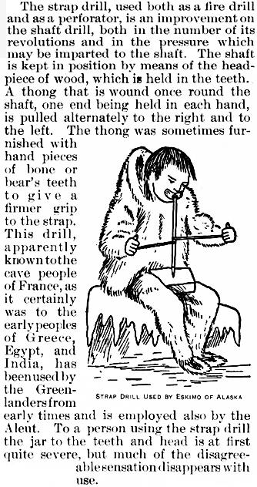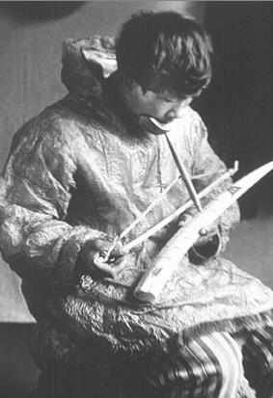

# Late nineteenth century Inuit Craftsman using a strap drill to engrave a piece of ivory.http://www.takeadiptools.com/attachments/Image/BOW_DRILLS/eskimo_using_bowdrill.jpg

Reference:

# Joseph D. McGuire, "Drills and Drilling," in Frederick Webb Hodge, *Handbook of American Indians north of Mexico,* Bulletin (Smithsonian Institution. Bureau of American Ethnology, 30. Washington : G.P.O., 1907-1910, p. 403.